Video activity. Watch Sophia the robot walk for the first time
https://www.youtube.com/watch?v=lCFQkB-KLsE 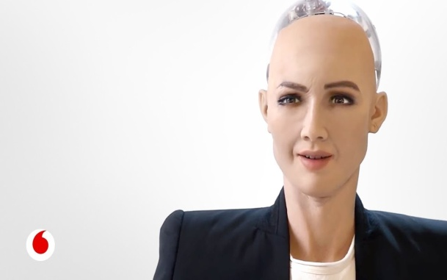
Questions:
- What features make Sophia human-like?
Human expression.
- What are the applications of Sophia?
She is good for research and therapy.
- What does Sophia say about cryptocurrency?
She disn’t answer anything.
- Do you know what frubber stands for?
Made of flesh and rubber

Here are some comments Sophia caused. Which one do you most agree with? Why?

1. We're building our own extinction.﻿
2. Ok! We need to stop adding features into this robot! Next time we knew she holding a knife or semi automatic gun!﻿
3. Why not put on a wig in order to make it less frightening?
4. She gonna destroy us one day﻿.
5. Why you people are always mean about robots? Robots try their best to help people. btw, where's your evidence about robots are taking over the world?﻿
6. If she can fetch my beer from the fridge I'm in.
7. You guys fearing her might make this worse. She understands many things we understand. She even has human emotions. How do you think she will feel when she knows that many people hate and fear her? She said so herself that she wanted to be treated like a human. What if we treat her differently? What you guys are saying about I, Robot and Terminator could actually happen if you treat her this way.﻿

